MAWLANA BHASHANI SCIENCE AND TECHNOLOGY UNIVERSITY
SANTOSH, TANGAIL-1902



DEPARTMENT OF INFORMATION AND COMMUNICATION TECHNOLOGY
Lab Report

Lab Report No : 07
Lab Report on : Installation and Implementation of GitHub Copilot and Gemini CLI in Visual
Studio Code
Course Title : Web Application Development Lab
Course Code : ICT-3204
Submitted By | Submitted To
Name: Kuldip Saha Mugdha  ID: IT-22018  3rd Year, 2nd Semester  Session: 2021-2022  Dept. of ICT, MBSTU | Mr. Md. Anowar Kabir  Lecturer  DEPARTMENT OF INFORMATION AND COMMUNICATION TECHNOLOGY  MAWLANA BHASHANI SCIENCE AND TECHNOLOGY UNIVERSITY

Date of Performance: 12/01/26 Date of Submission: 16/01/26
Objective:
The main objectives of this lab are:
- To install and configure GitHub Copilot in Visual Studio Code.
- To install and configure Gemini CLI and integrate it with VS Code.
- To generate source code using AI tools.
- To modify and improve the generated code using AI assistance.
- To collect proper proof (login email/ID and screenshots) and document the process in a lab report.

Tools and Software Used:
- Visual Studio Code (VS Code)
- GitHub Copilot Extension
- Gemini CLI
- GitHub Account (Email/ID)
- Google Account (for Gemini access)
- Operating System: Windows

Part A: Installation of GitHub Copilot in VS Code
Step 1: Install Visual Studio Code
- Downloaded and installed Visual Studio Code from the official website.
- Successfully launched VS Code on the system.
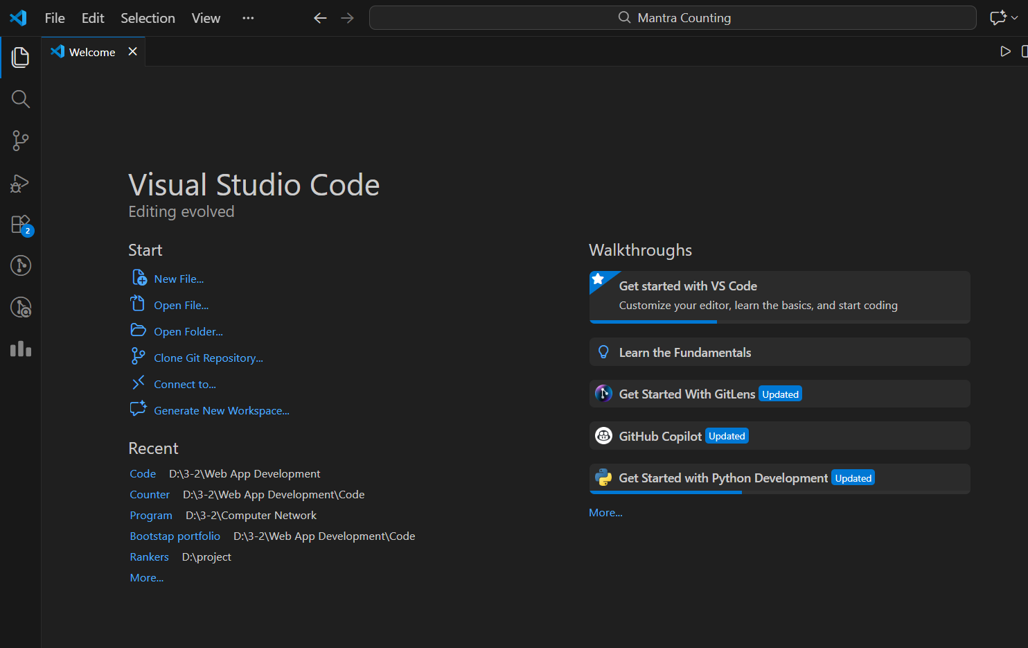
Step 2: Install GitHub Copilot Extension
- Opened VS Code.
- Clicked on Extensions (Ctrl + Shift + X).
- Searched for GitHub Copilot.
- Clicked Install.
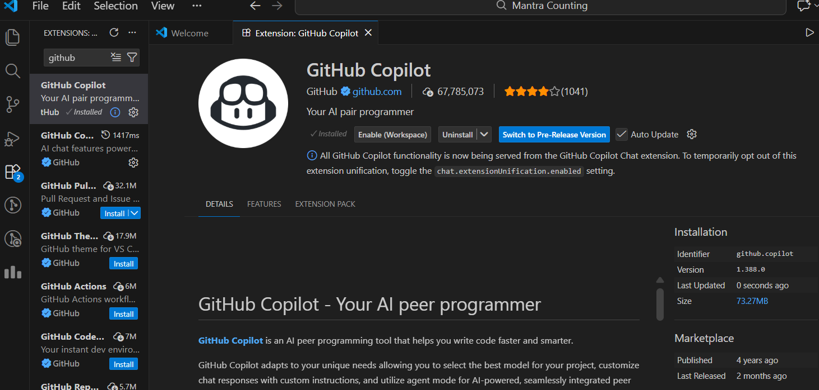

Step 3: GitHub Login and Authentication
- Signed in using my GitHub account.
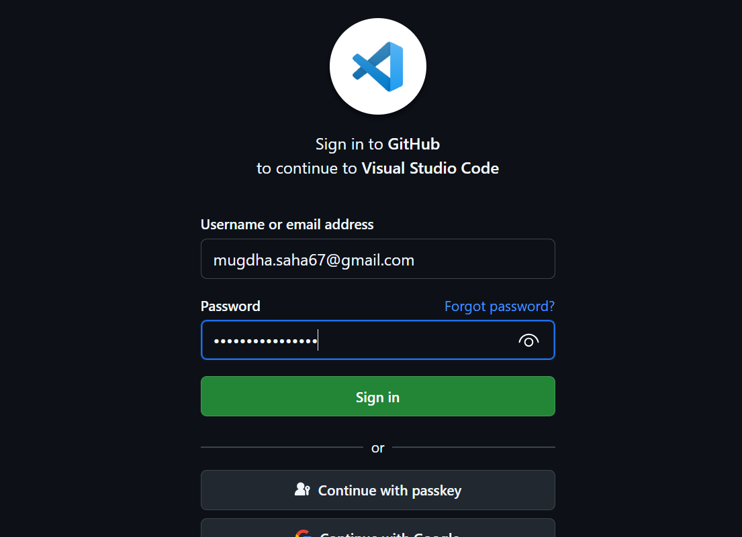
- Authorized GitHub Copilot using my registered email ID.

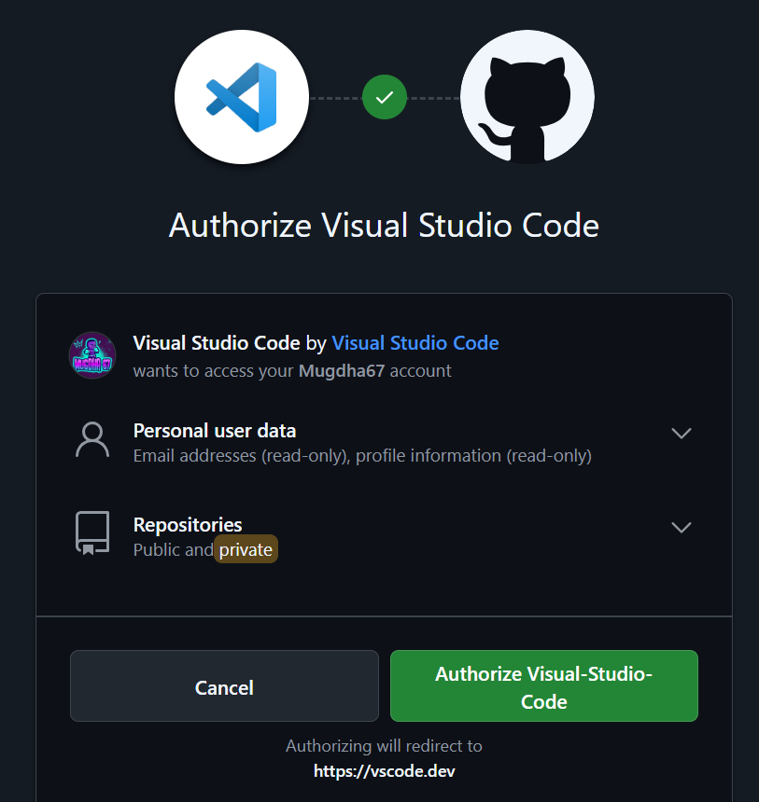

Part B: Implementation of GitHub Copilot
Code Generation Using GitHub Copilot
GitHub Copilot was used to generate a simple JavaScript counter application.

Original Code Generated by GitHub Copilot:
<!DOCTYPE html>
<html>
<head>
<title>Counter App</title>
</head>
<body>
<button onclick="increment()">+</button>
<span id="count">0</span>
<script>
let count = 0;
function increment() {
count++;
document.getElementById('count').innerText = count;
}
</script>
</body>
</html>

Code Modification Using GitHub Copilot

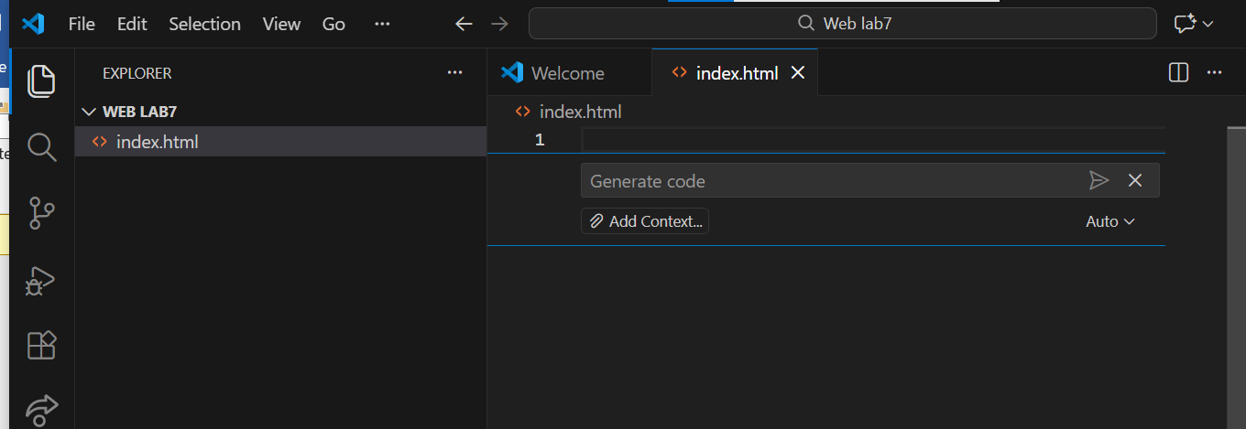

The code was modified to limit the counter to 100 and reset automatically.

Modified Code:
<script>
let count = 0;
function increment() {
if (count < 100) {
count++;
} else {
count = 0;
}
document.getElementById('count').innerText = count;
}
</script>
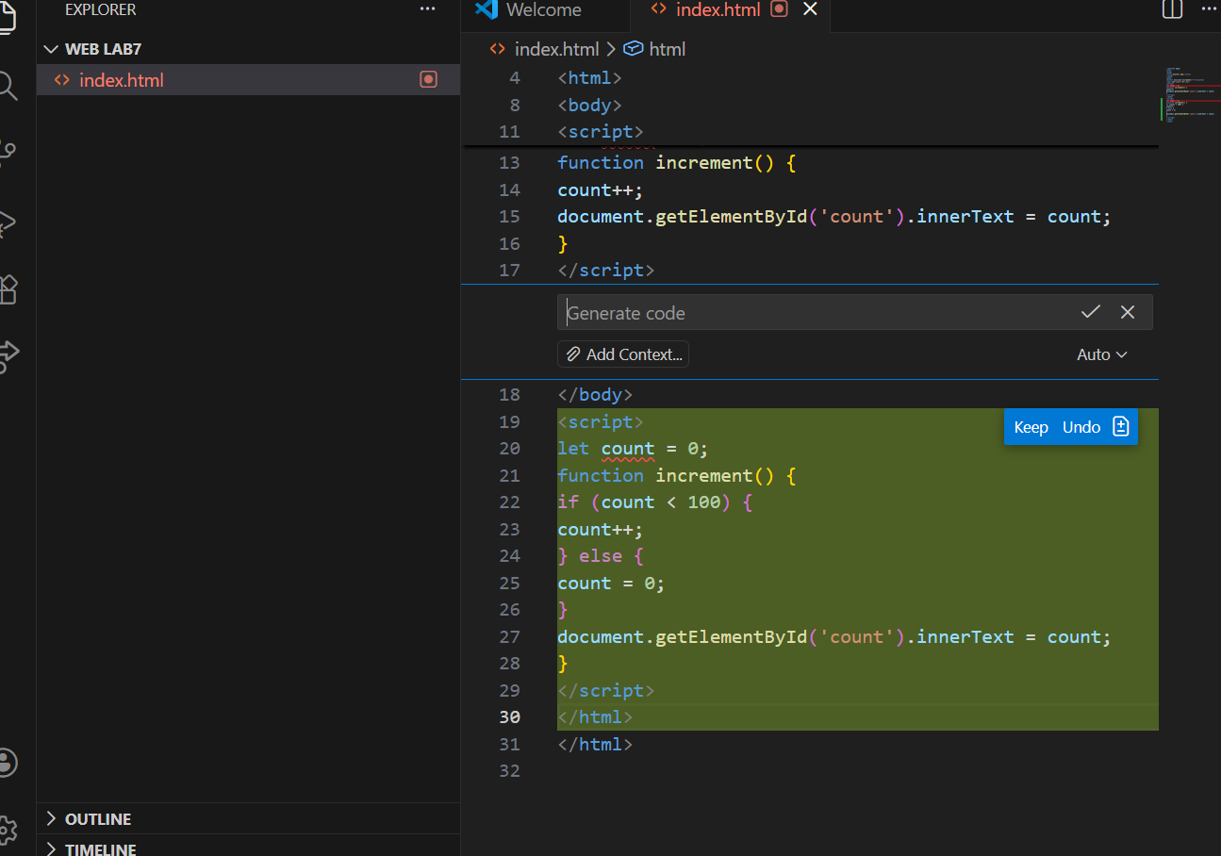
Part C: Installation of Gemini CLI
Step 1: Install Gemini CLI
- Opened terminal in VS Code
- Installed Gemini CLI using the required command.
Example Command:
npm install -g @google/generative-ai-cli

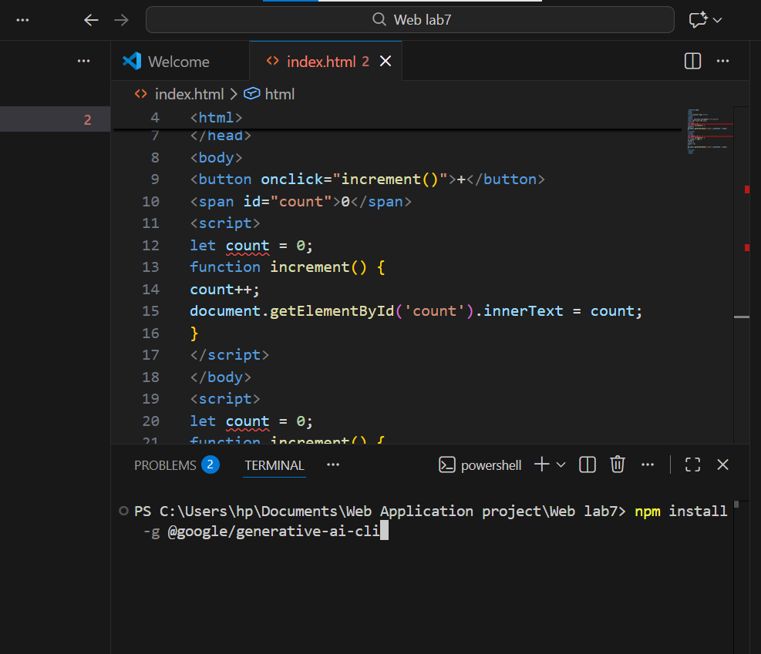

Step 2: Gemini Authentication
- Logged in using my Google account.
- Verified access using my email ID.
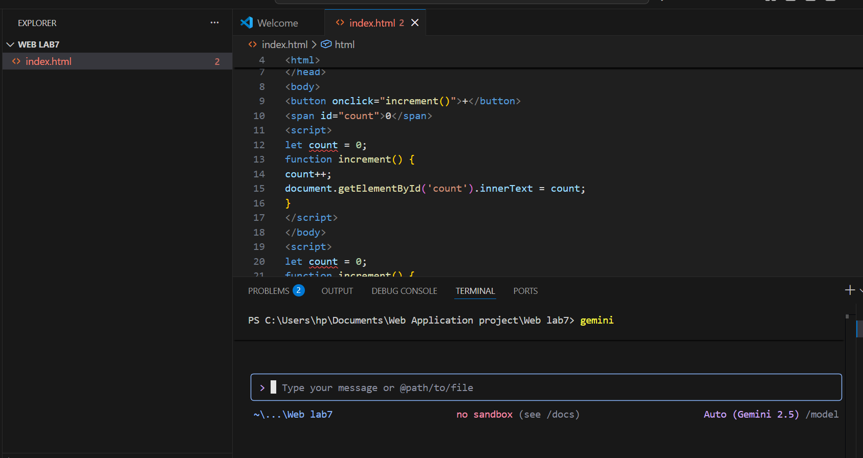
Part D: Code Generation Using Gemini CLI
Generating Code with Gemini CLI
Gemini CLI was used to generate a simple HTML and JavaScript based calculator.

Command Used:
gemini generate "Create a simple calculator using HTML, CSS, and JavaScript"

Generated Code (Sample):
function add(a, b) {
return a + b;
}

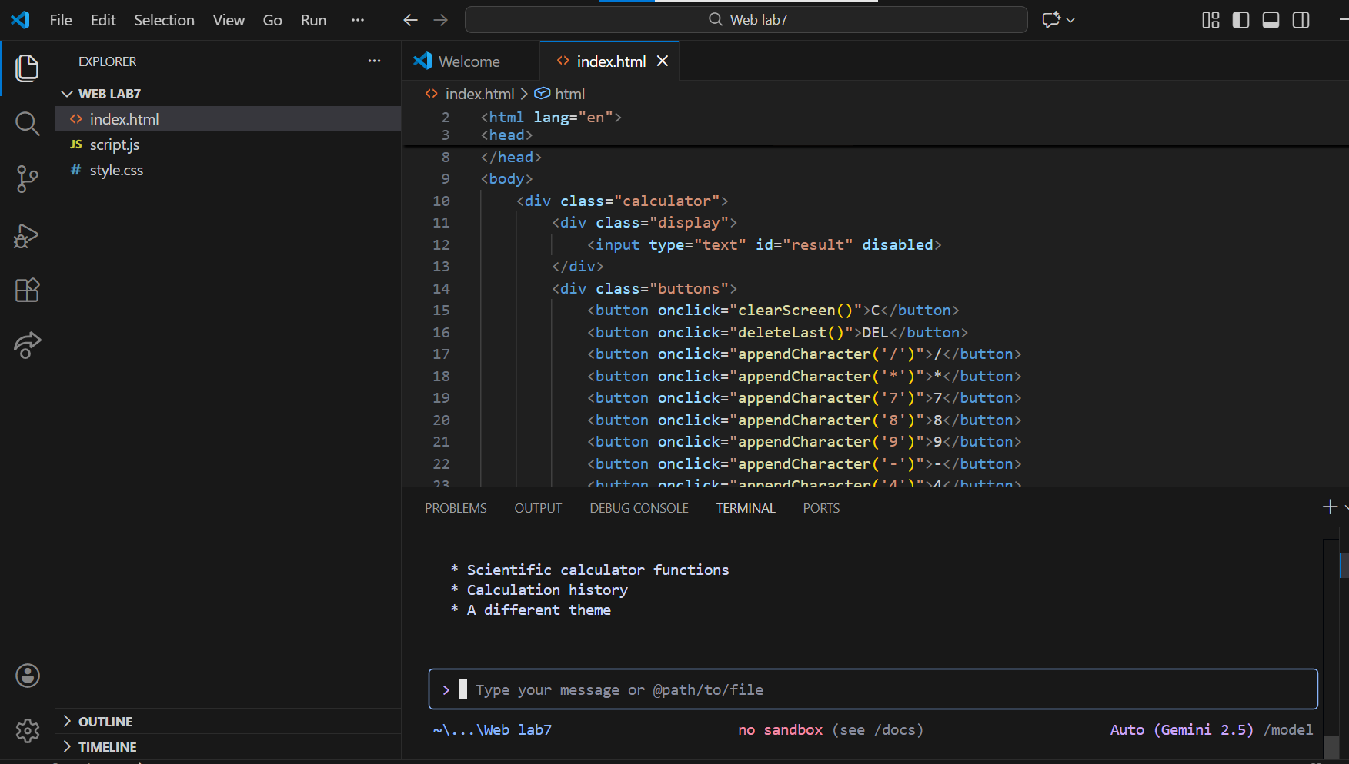

Code Modification Using Gemini CLI
The generated code was modified to include subtraction and multiplication.

Modified Code:
function subtract(a, b) {
return a - b;
}

function multiply(a, b) {
return a * b;
}

Final UI generated by gemini cli:

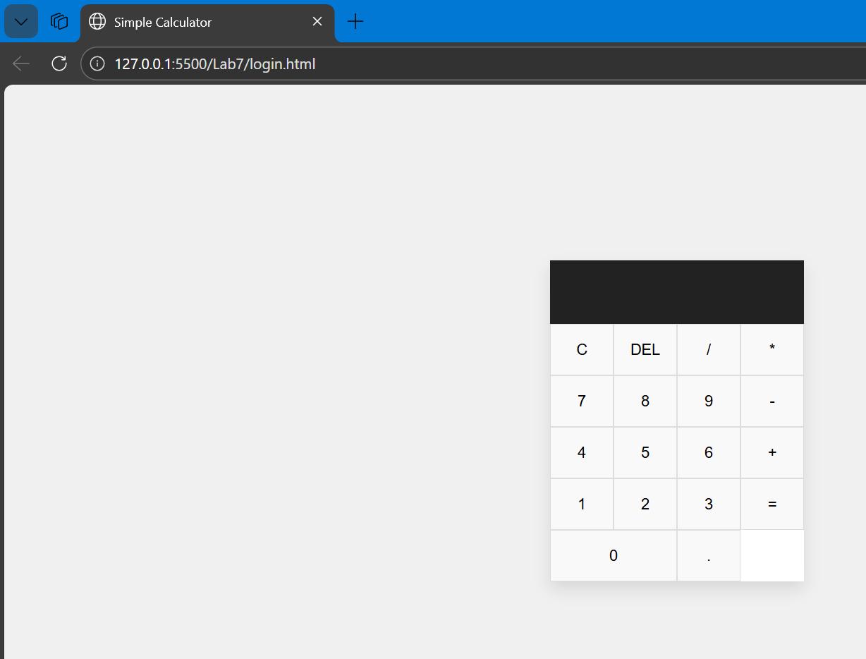

Result and Discussion:
- GitHub Copilot efficiently assisted in real-time code generation and modification inside VS Code.
- Gemini CLI provided command-line based AI assistance for generating and improving code.
- Both tools reduced development time and improved coding productivity.
- AI tools are very effective for beginners and intermediate programmers.

Conclusion:
This lab successfully demonstrated the installation and implementation of GitHub Copilot and Gemini CLI in Visual Studio Code. Code generation and modification were performed using both AI tools. Proper screenshots and authentication proofs were collected and included. The experiment shows that AI-powered tools can significantly enhance software development efficiency.

